**POWER BI PROJECT**

**NAME : Tuhin John**

**USN: 22BTRCL157**

**Step 1: Load and Explore the Data**  
Import the "Sales_Data.csv" file into PowerBI.  
Familiarize yourself with the dataset. Identify the key columns that will be used in our analysis.

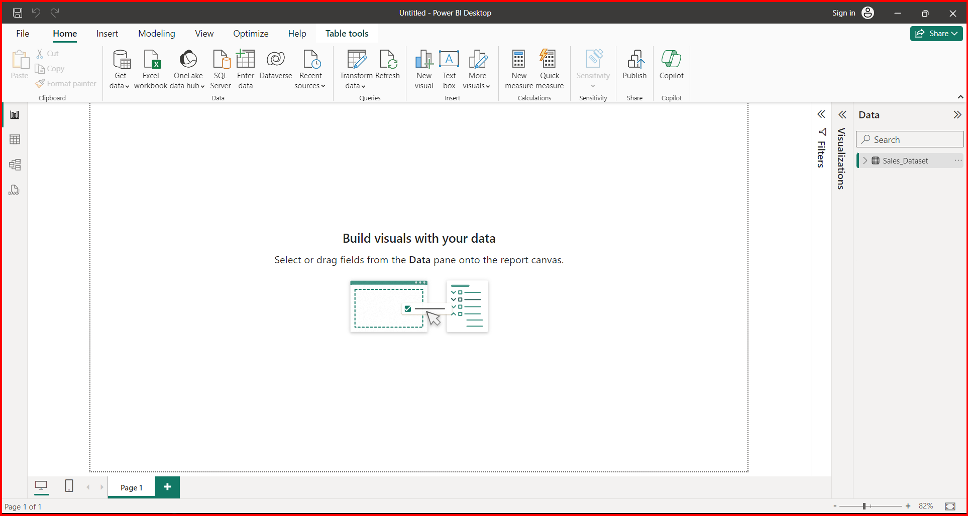  
  
**Step 2: Data Transformation**  
Create a new column for "Month-Year" from the "Date" column for better aggregation in visuals.  
Calculate "Month-on-Month Growth" in sales to understand the growth pattern.

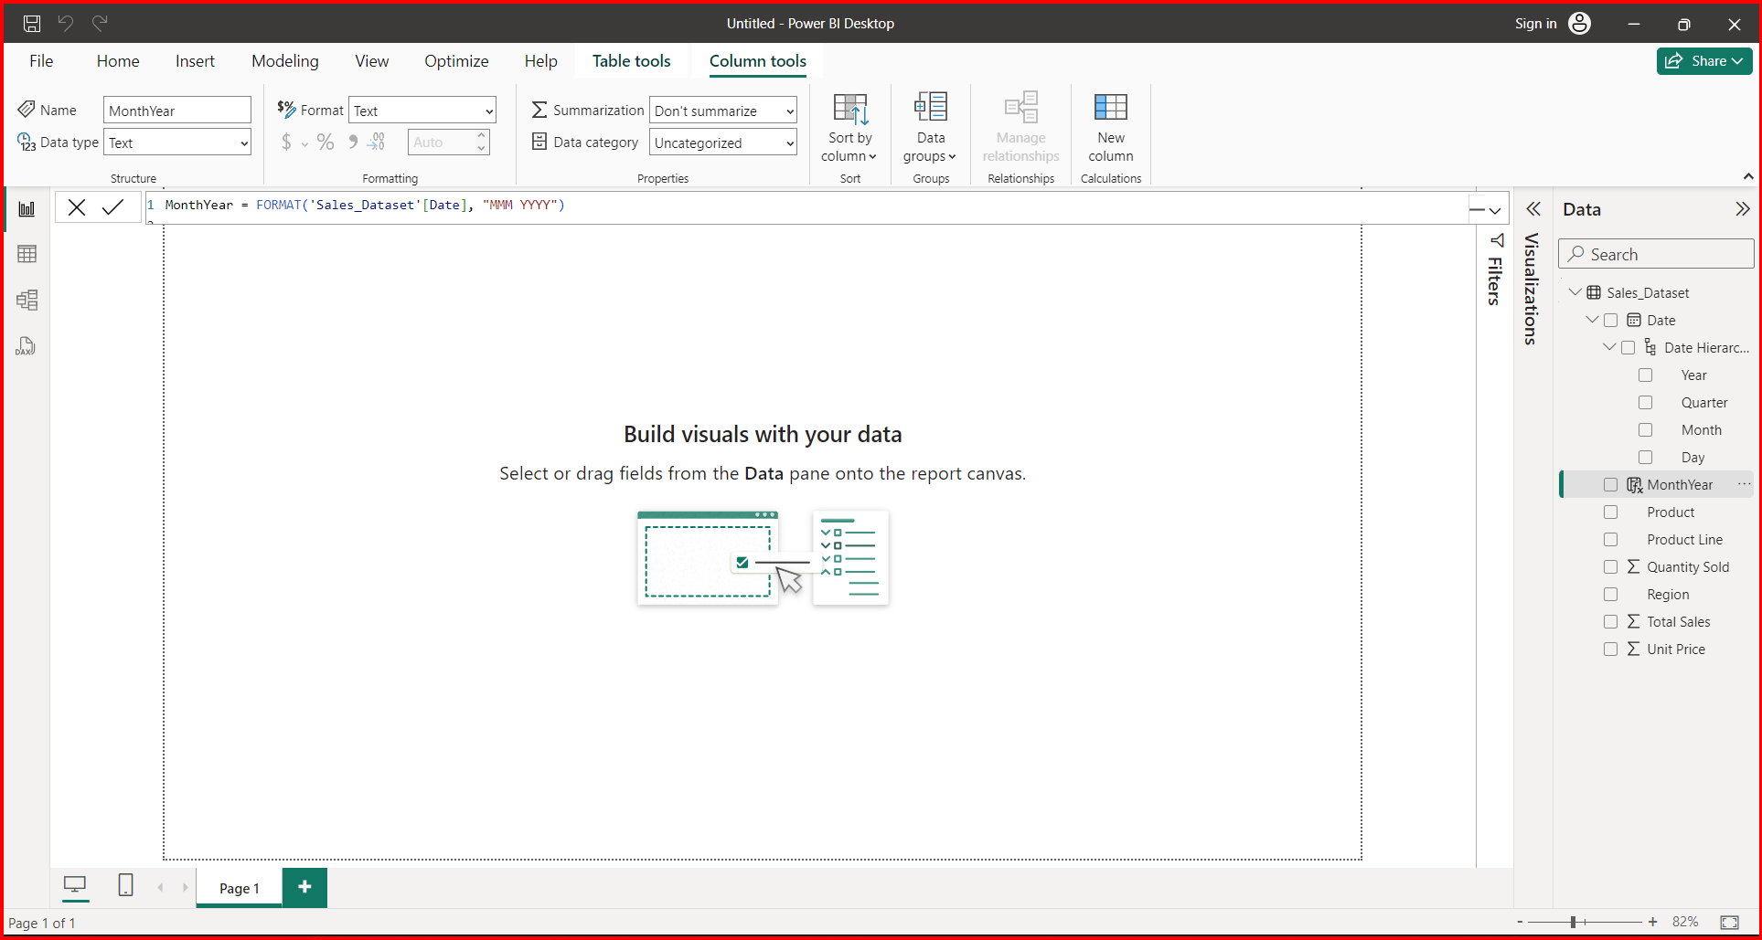

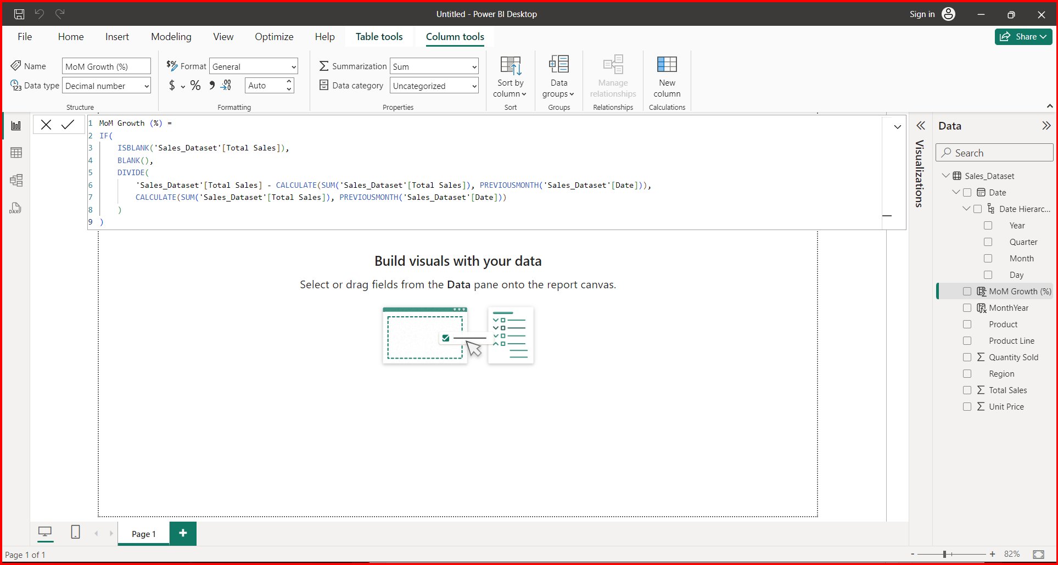

**Step 3: Building the Dashboard**  
Your dashboard will consist of the following visual elements:  
**3.1 Sales Trends Over Time**  
🡪 Create a line chart to display total sales over time. This will help the management team to understand the overall sales trend.

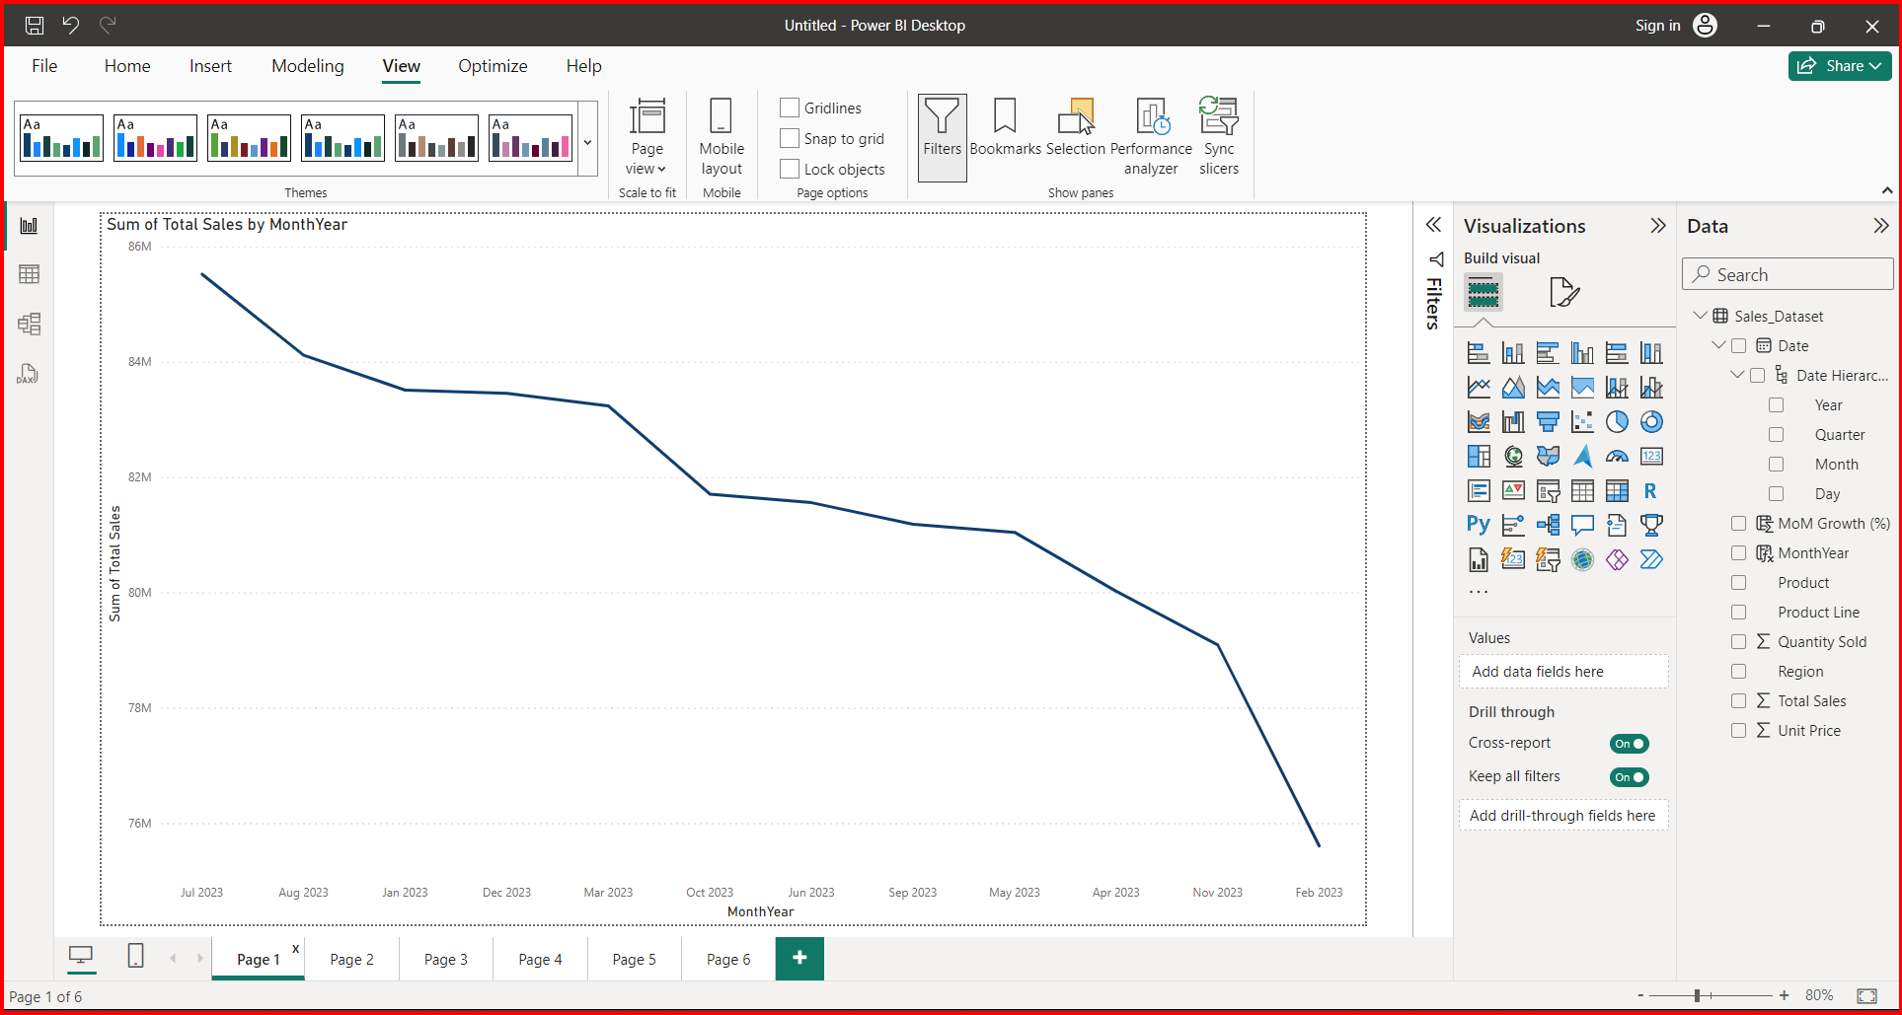  
**3.2 Regional Performance Comparison**  
🡪 Use a bar chart to compare the total sales across different regions. This will highlight which regions are performing well and which are lagging.

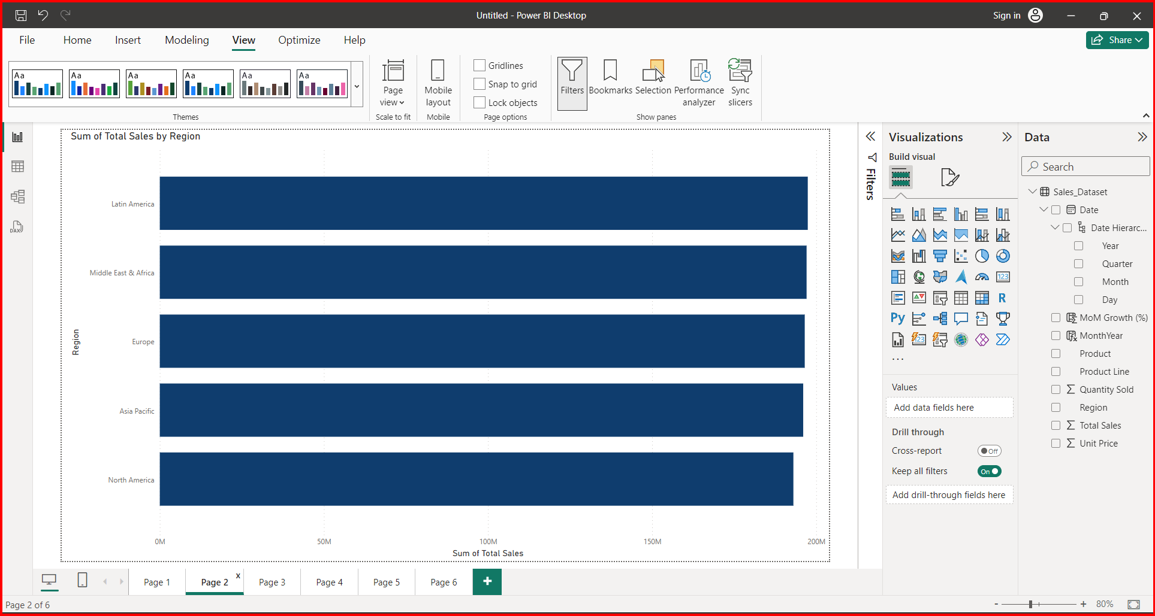  
**3.3 Sales Breakdown by Product Line**  
🡪 Design a pie chart to show the sales contribution of each product line. This visual will help in understanding the product line's performance.

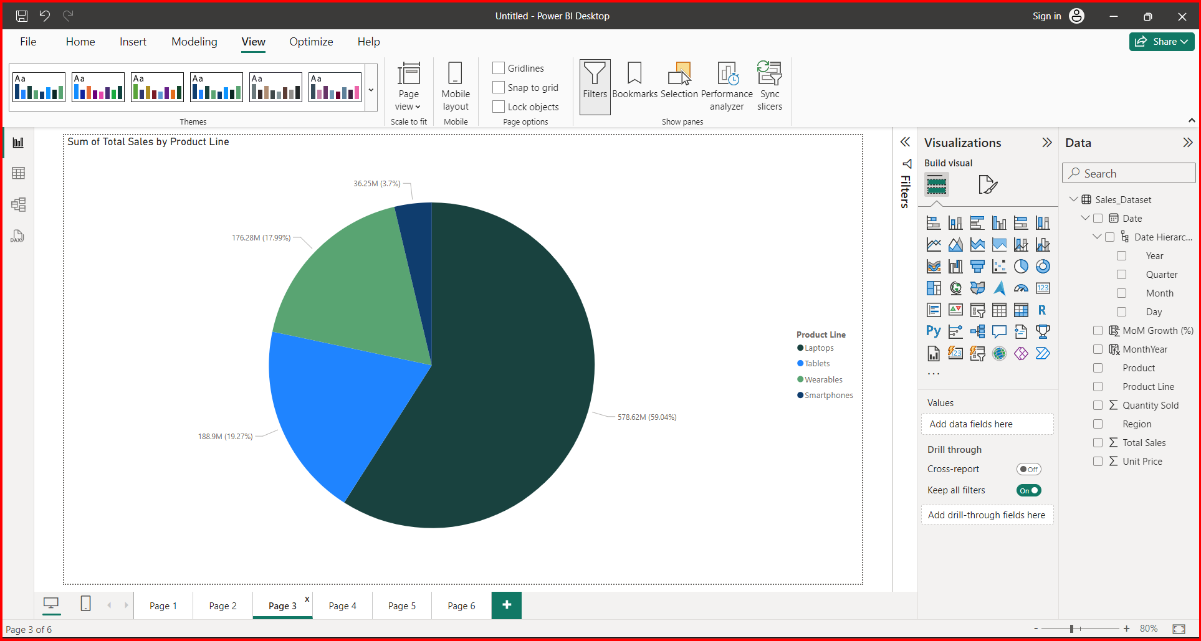

**3.4 Top and Bottom Performing Products**  
🡪 Implement a table or a bar chart to list the top 5 performing products based on total sales.  
🡪 Similarly, list the bottom 5 performing products to identify areas of concern.

**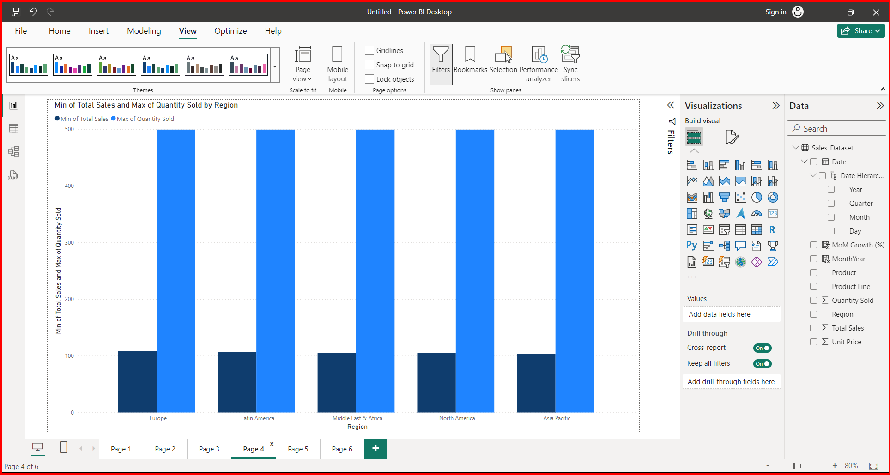  
3.5 Month-on-Month Sales Growth**  
🡪 Create a column chart to represent the Month-on-Month sales growth. Use a color scheme to differentiate between positive and negative growth.

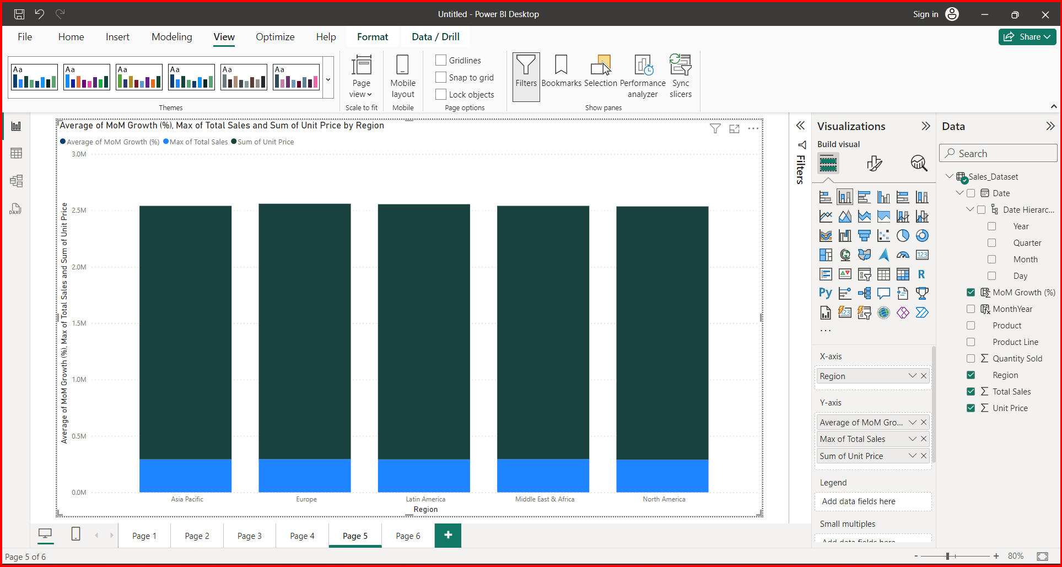

**Step 4: Interactivity and Filtering**  
🡪 Add slicers for "Region" and "Product Line" to allow the management team to filter the dashboard and drill down into specific areas of interest.  
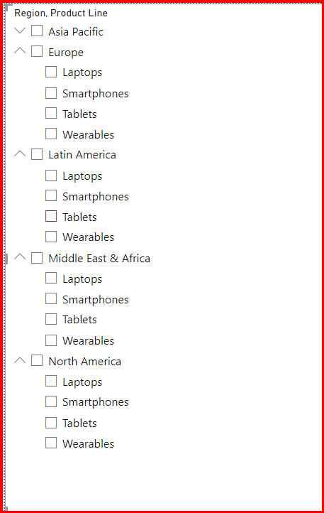  
**Step 5: Insights and Observations**  
🡪 Based on the visualizations, provide at least three insights or observations that could be valuable for the management team. These could relate to trends, anomalies, or opportunities suggested by the data.

